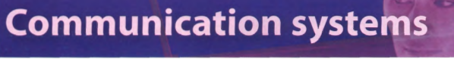
Task 11

- Translate the text.
- Complete the exercises.
- Make up the glossary of the words given in the bold font.



